Prompt_set.py
minor_changes: 3 pairs
different_wording_same_meaning: 3 pairs
look_similar_diff_computation: 3 pairs
unrelated: 3 pairs
Total pairs: 12

Inspect_hidden_states.py
Prompt: 'Calculate 17 x 23' (8 tokens)

type(hidden_states): <class 'tuple'>
Number of layers in hidden_states tuple: 25
Shape of hidden_states[0]: torch.Size([1, 8, 896])
Shape of hidden_states[-1]: torch.Size([1, 8, 896])
dtype: torch.bfloat16

- Type(hidden_states): the tuple instead of past_key_values
- 1 more layers than the model’s 24 transformer layers. Hidden_states[0] is the embedding output, the raw per token vectors right after the input tokens get converted into vectors, before the transformers touch them.There is
- Batch size 1, 8 tokens (map from the prompt), 896 dimensional vector per token (this matched with Qwen’s hidden size in last step).
- The [-1] is to show that the shape never changes as the data flows through the network

Why pooling matters: pooling happens after the forward pass of the transformer layers is done, on data that would be extracted.
Either throw away all the position vectors except for the last one, or average across the position dimension. They are array slicing/averaging on the same underlying data – no model weights, no attention, no computation graph.
Pooling strategy: last token pooling because qwen is an autoregressive model, so the last token’s hidden state has technically seen every prior token through attention.
Similarity metric: cosine similarity, measure the angle between two vectors, resulting in a bounded score from -1 to 1, or 0 to 1 for hidden states. => direction in representation space.
I also did mean pooling to compare the results.
- 1.0 means perfectly identical vectors, not different.
Pooling.py
A: 'Calculate 17 x 23'
B: 'Compute 17 x 23'

layer | last-token sim | mean-pool sim
---------------------------------------------
0 | 1.0000 | 0.9887
1 | 0.9989 | 0.9692
2 | 0.9955 | 0.9705
3 | 0.9955 | 0.9998
4 | 0.9949 | 0.9999
5 | 0.9934 | 0.9999
6 | 0.9937 | 0.9999
7 | 0.9951 | 0.9999
8 | 0.9952 | 0.9999
9 | 0.9952 | 0.9999
10 | 0.9954 | 0.9999
11 | 0.9945 | 0.9999
12 | 0.9937 | 0.9999
13 | 0.9927 | 0.9999
14 | 0.9921 | 0.9999
15 | 0.9890 | 0.9999
16 | 0.9870 | 0.9999
17 | 0.9856 | 0.9999
18 | 0.9851 | 0.9998
19 | 0.9845 | 0.9998
20 | 0.9831 | 0.9997
21 | 0.9849 | 0.9996
22 | 0.9876 | 0.9911
23 | 0.9854 | 0.9898
24 | 0.9815 | 0.9856

Last token sim: about 0.98 -> 1.0, dip around mid to late layers, but then it recovers at the end, since the last token in both prompts is 23 and they are in identical positions, while the wording difference reaches it indirectly through attention. So, from the model’s current summary perspective, the two prompts look nearly identical at every depth.
Mean-pool similarity: from 0 -> 1: it is about the lower bound compared to the rest of the layers, since it is in the embedding layer, so calculate and compute are fairly distinct token embeddings. From 3 -> 21, it’s nearly perfect, the two prompts’ average representation becomes almost identical, somehow, they folded calculate and compute into a shared semantic representation despite the different surface tokens. From 22 -> 24, it’s specialized toward predicting the next token, which brings back some sensitivity to the exact wording used.
Tested with an unrelated prompt:
A: 'Calculate 17 x 23'
B: 'Alice has a MacBook and a Windows.'

layer | last-token sim | mean-pool sim
---------------------------------------------
0 | 0.4334 | 0.3863
1 | 0.1993 | 0.6146
2 | 0.3114 | 0.7051
3 | 0.2602 | 0.9979
4 | 0.2857 | 0.9994
5 | 0.2947 | 0.9992
6 | 0.3132 | 0.9991
7 | 0.3066 | 0.9991
8 | 0.2825 | 0.9989
9 | 0.2923 | 0.9989
10 | 0.3613 | 0.9989
11 | 0.3364 | 0.9988
12 | 0.2908 | 0.9988
13 | 0.4038 | 0.9987
14 | 0.4111 | 0.9986
15 | 0.4122 | 0.9983
16 | 0.3892 | 0.9981
17 | 0.4949 | 0.9972
18 | 0.5160 | 0.9963
19 | 0.5566 | 0.9955
20 | 0.5576 | 0.9944
21 | 0.6139 | 0.9915
22 | 0.7120 | 0.8310
23 | 0.6915 | 0.8215
24 | 0.4379 | 0.5132

When it looks similar but have a different computation, here’s the result:
A: 'Calculate 17 x 23'
B: 'Calculate 17 + 23'

layer | last-token sim | mean-pool sim
---------------------------------------------
0 | 1.0000 | 0.9822
1 | 0.9987 | 0.9726
2 | 0.9702 | 0.9691
3 | 0.9470 | 0.9998
4 | 0.9391 | 0.9999
5 | 0.9161 | 0.9999
6 | 0.9363 | 0.9999
7 | 0.9498 | 0.9999
8 | 0.9196 | 0.9999
9 | 0.9260 | 0.9999
10 | 0.9172 | 0.9999
11 | 0.9107 | 0.9999
12 | 0.9090 | 0.9999
13 | 0.9221 | 0.9999
14 | 0.9306 | 0.9999
15 | 0.9429 | 0.9999
16 | 0.9414 | 0.9999
17 | 0.9378 | 0.9998
18 | 0.9387 | 0.9998
19 | 0.9441 | 0.9997
20 | 0.9506 | 0.9997
21 | 0.9522 | 0.9996
22 | 0.9614 | 0.9916
23 | 0.9549 | 0.9910
24 | 0.9418 | 0.9874

The mean pooling method shows that at the middle layers when its 17 x 23 and 17 + 23, it hits the same near perfect value of 0.99999 even though the computation is different. They share the same token?

The last token method shows that it drops to about 0.91 to 0.95 compared to the control pair as before. The dip happens throughout most of the middle layers.

Sweep_result.py:
category | pair | last-tok avg | mean-pool avg
----------------------------------------------------------------------
minor_changes | 0 | 0.9911 | 0.9999
minor_changes | 1 | 0.9933 | 0.9999
minor_changes | 2 | 0.9905 | 0.9999
different_wording_same_meaning | 0 | 0.4130 | 0.9981
different_wording_same_meaning | 1 | 0.4109 | 0.9981
different_wording_same_meaning | 2 | 0.4184 | 0.9982
look_similar_diff_computation | 0 | 0.9332 | 0.9998
look_similar_diff_computation | 1 | 0.9312 | 0.9998
look_similar_diff_computation | 2 | 0.8878 | 0.9999
unrelated | 0 | 0.3515 | 0.9985
unrelated | 1 | 0.3505 | 0.9988
unrelated | 2 | 0.3368 | 0.9983
Last token pooling is the viable option here as it tracks “do the two prompts end in the same token”, more than semantic content. Mean pooling is at saturated regardless of the content, so neither of the method captures semantic similarity in a meaningful way.

When change the prompt_set.py in different wording same meaning sets (removed the question mark at the end of the one side of the set)
category | pair | last-tok avg | mean-pool avg
----------------------------------------------------------------------
minor_changes | 0 | 0.9911 | 0.9999
minor_changes | 1 | 0.9933 | 0.9999
minor_changes | 2 | 0.9905 | 0.9999
different_wording_same_meaning | 0 | 0.8114 | 0.9986
different_wording_same_meaning | 1 | 0.6939 | 0.9985
different_wording_same_meaning | 2 | 0.6352 | 0.9986
look_similar_diff_computation | 0 | 0.9332 | 0.9998
look_similar_diff_computation | 1 | 0.9312 | 0.9998
look_similar_diff_computation | 2 | 0.8878 | 0.9999
unrelated | 0 | 0.3515 | 0.9985
unrelated | 1 | 0.3505 | 0.9988
unrelated | 2 | 0.3368 | 0.9983

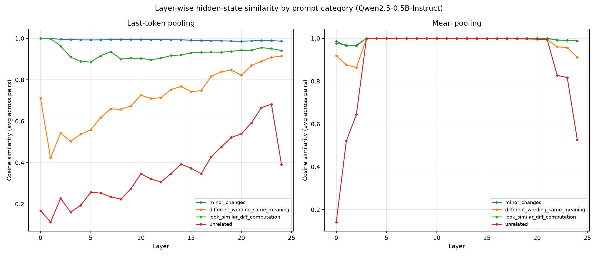

- Qwen2.5-0.5B’s hidden states encode semantic similarity independently of the surfacing words, but only visible through last token pooling and only after controlling for a sentence final token artifact.

